Find command

Fine /home name “sample.txt”

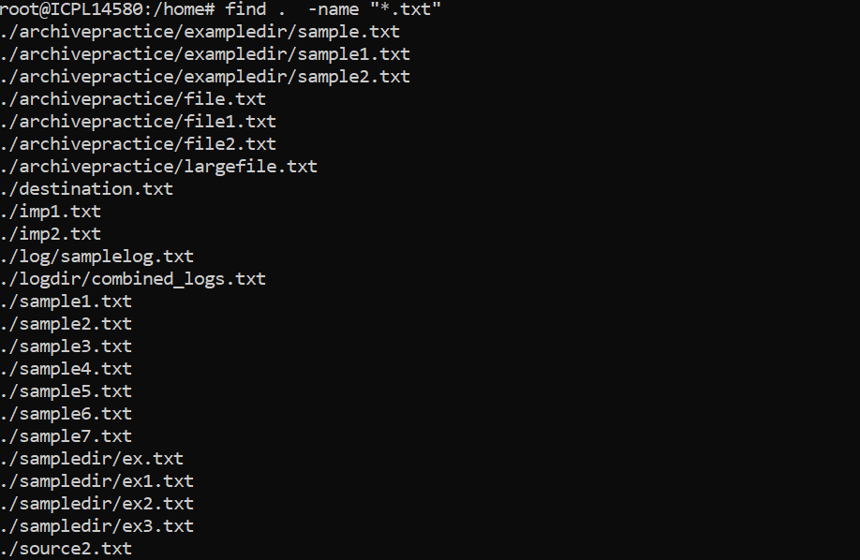

find /home -iname "example.txt"



find /home -type d

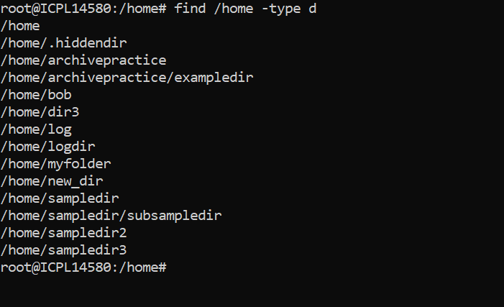

find /home -type f

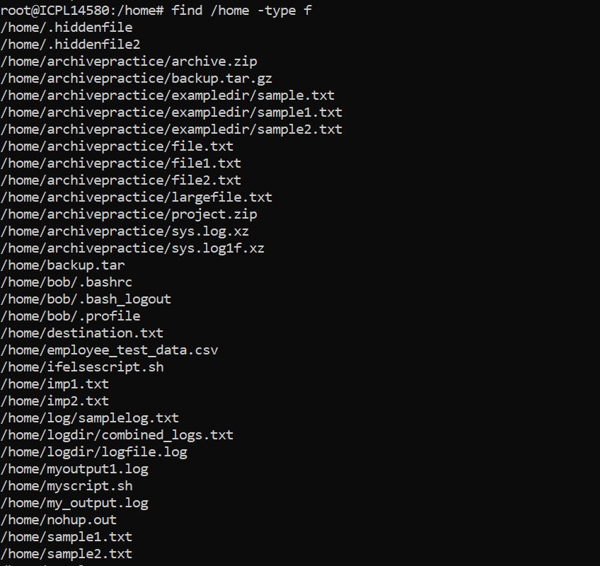

find /var/log -type f -size +10M

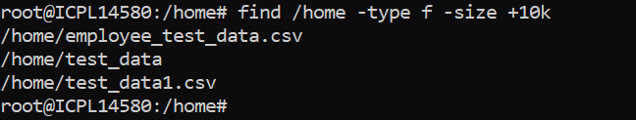

find /var/log -type f -size –1M

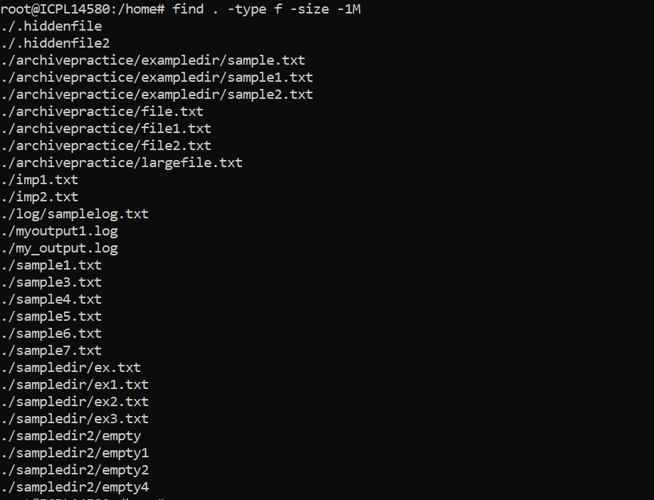

find /var/log -type f -mtime –7

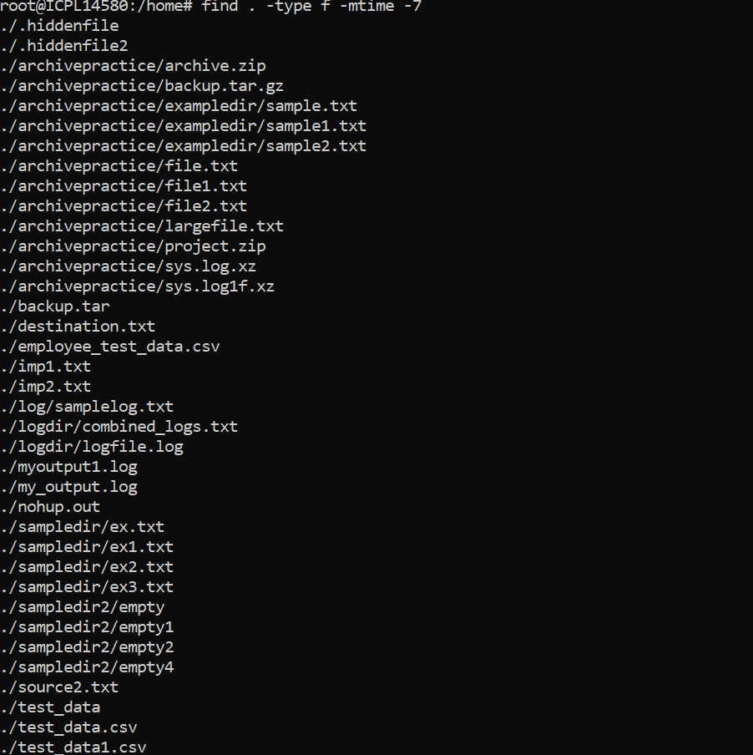

find /var/log -type f -mtime +30

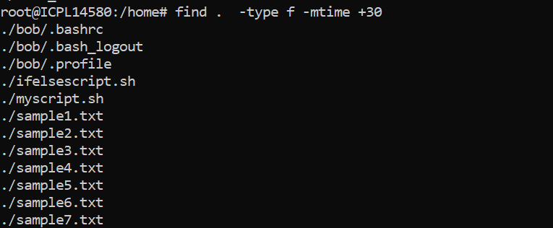

find /tmp -type f -mtime +30 –delete instead of delete using print option

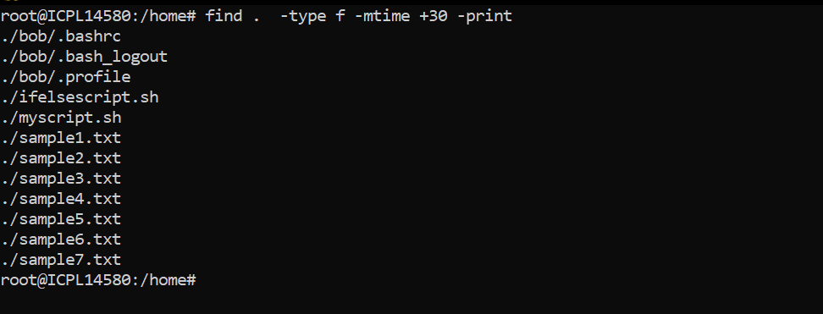

find /home -type f -name "\*.log" -exec cat {} \;

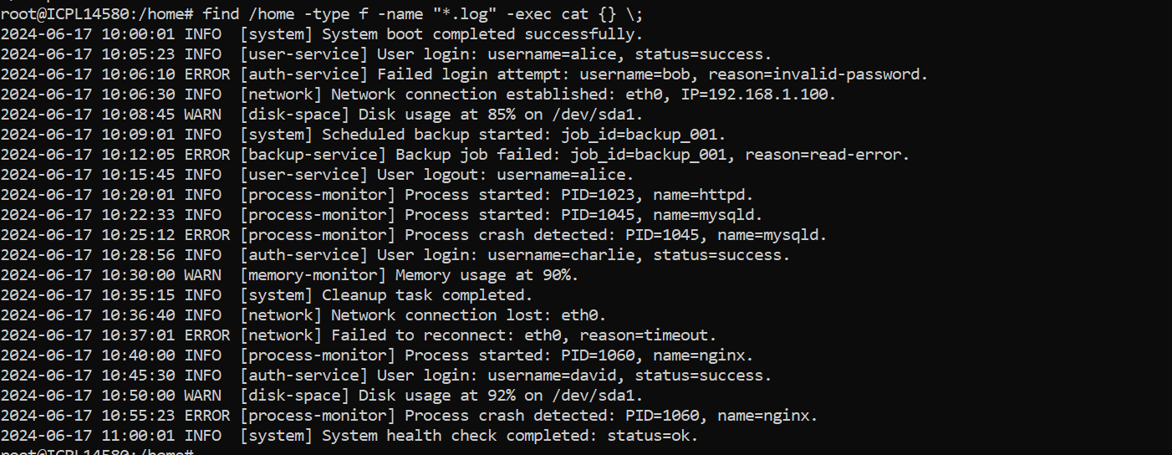

find /var/www -type f -name "\*.sh" -exec chmod 755 {} \;

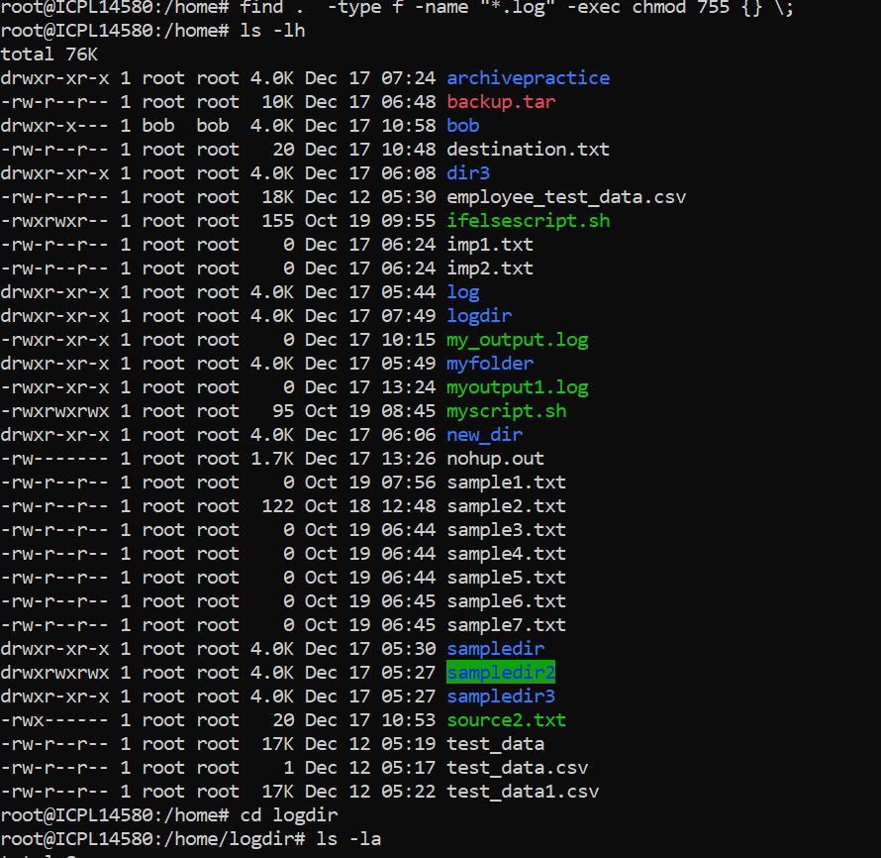

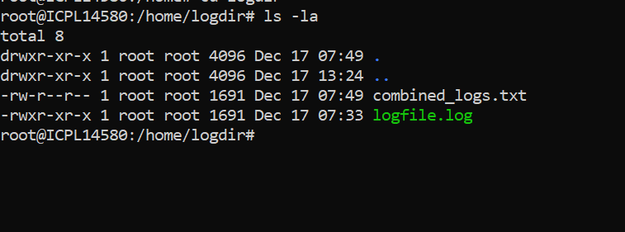

find /home -type f -name "\*.txt" -exec mv {} /backup/ \;

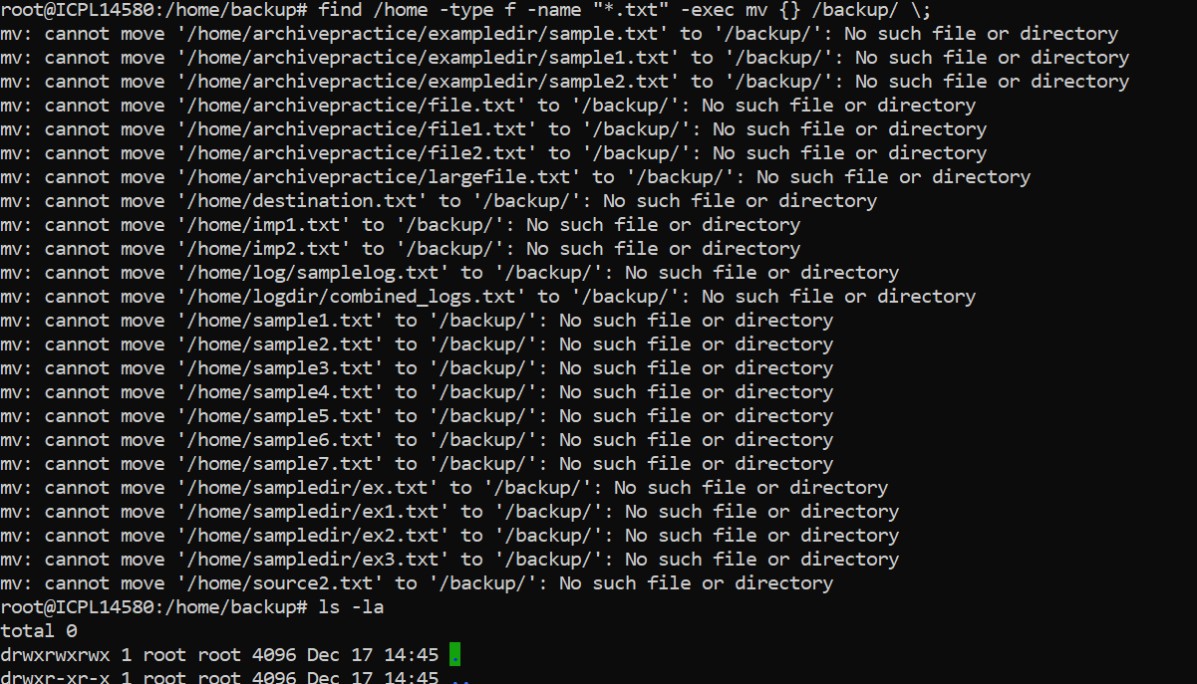

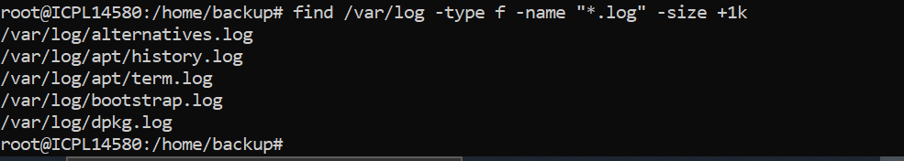

find /home -type f -mtime -7 -user user1

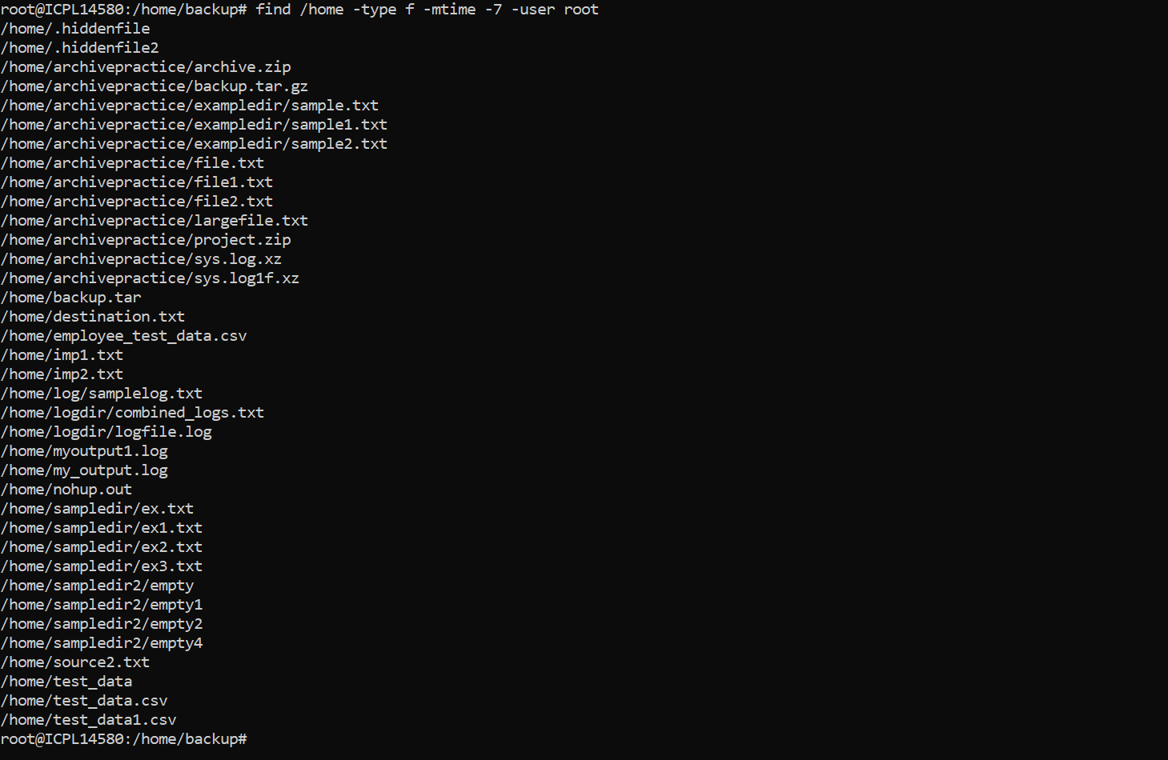

find /var/log -type f -exec du -h {} + | sort -rh | head -n 10

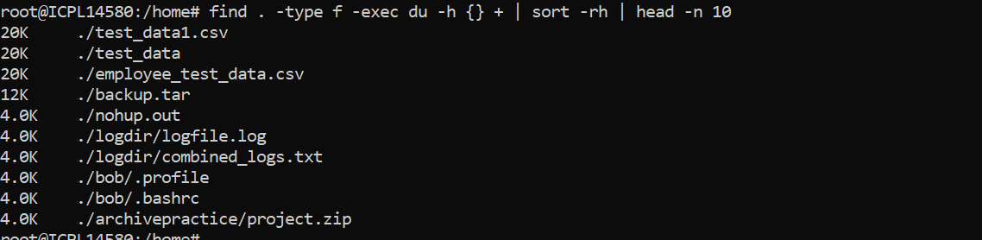

find /var/log -type f -name "*.log" -not -path "/var/log/archive/*"

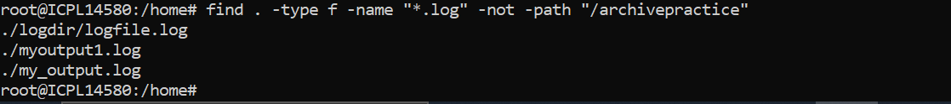

find /var/log -type f -mtime +7 -mtime –14

find /var/log -type f -mtime +7 -mtime –14

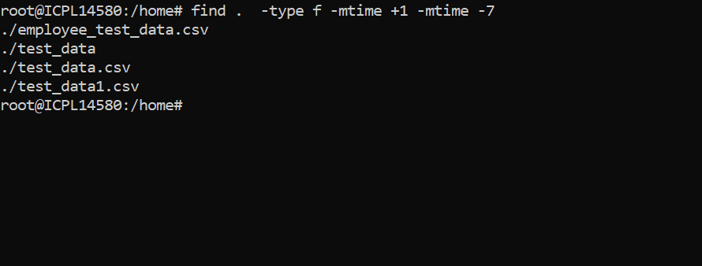

find /var/log -type f -name "\*.log" -exec gzip {} \;

Find all files under

/var

that are greater than 20 MB.

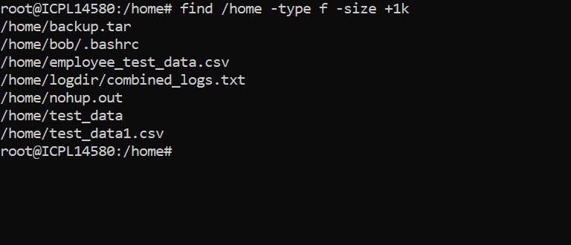

2.

Find all files under

/home

modified within the last 15 days.

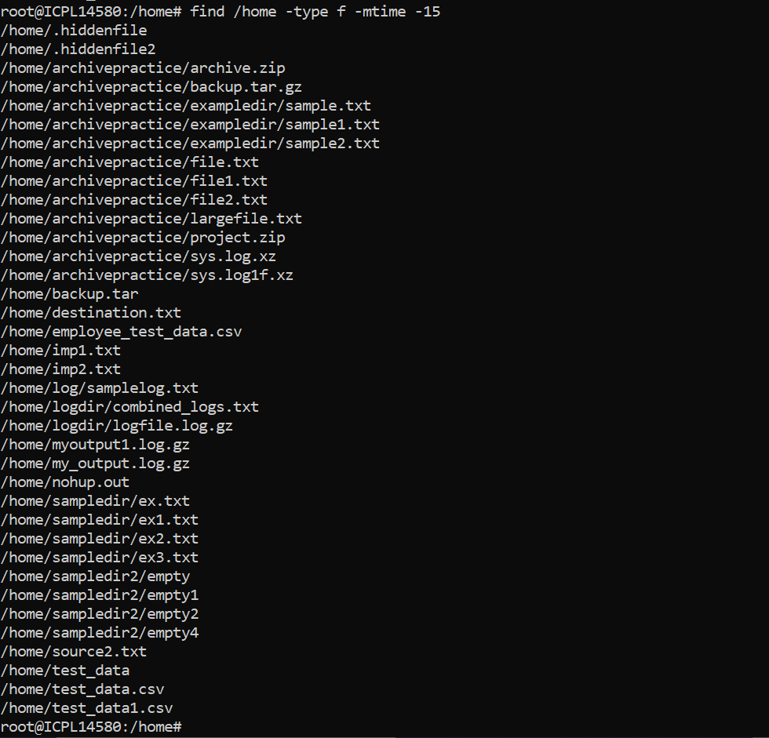

3.

Find files with

.log

extension and compress them.

find . -type f -name "\*.log" -exec gzip {} \;

4.

Find all files owned by user

admin

and delete them.

find / -type f -user admin -exec rm -f {} \;

5.

Find the 5 largest files under

/usr

and print their names and sizes.

find /usr -type f -exec du -h {} + | sort -rh | head -n 5

